GATHER

Site Selection Checklist

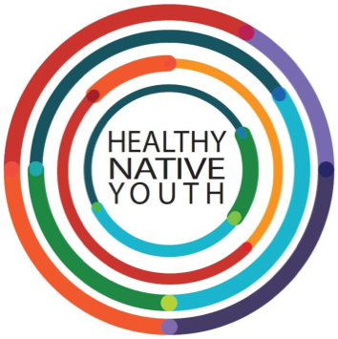

As you begin the selection process, think about the needs and resources you’ve identified in your community.
For some, the setting will be pretty straight forward – like in a school health class or during an existing after-school program. For others, there may be a few options that you’ll need to consider and choose between. Think through each of your options: Will you implement the program in a school setting or a community setting? Will you deliver the program in-person, virtually, or in a hybrid manner?
It never hurts to have a back-up plan, just in case your first choice falls through.

Instructions: Below is a simple resource to help you get started.

Source: Adapted from Trevino, N., & Gaston, A. 2020. Healthy Native Youth: Virtual Adaptation Guide. Portland, OR: Northwest Portland Area Indian Health Board. Section 1.5 Platform Selection.

Site Selection Checklist

 | Strengths | Challenges or Limitations | Available Teaching Tools | Other Pros and Cons
Option 1:
 | - Support from Leadership  - Structured Access to Youth  - Dedicated Space to meet  - Co-Facilitator | - Shared space  - Limited access  - Other: | - Classroom  - Computer lab  - Virtual Meeting Software  - Interaction Software  - Other: | - In school  - Afterschool  - In-person delivery  - Virtual delivery  - Hybrid delivery
Option 2:
 | - Support from Leadership  - Structured Access to Youth  - Dedicated Space to meet  - Co-Facilitator | - Shared space  - Limited access  - Other: | - Classroom  - Computer lab  - Virtual Meeting Software  - Interaction Software  - Other: | - In school  - Afterschool  - In-person delivery  - Virtual delivery  - Hybrid delivery
Option 3:
 | - Support from Leadership  - Structured Access to Youth  - Dedicated Space to meet  Co-Facilitator | - Shared space  - Limited access  - Other: | - Classroom  - Computer lab  - Virtual Meeting Software  - Interaction Software  - Other: | - In school  - Afterschool  - In-person delivery  - Virtual delivery  - Hybrid delivery
