GROW

Reflect on Program Implementation

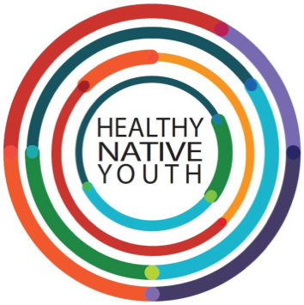

Instructions: Use this template to reflect on your program.
Reflecting on your program’s successes and challenges will open up new ideas for adaptation. Expanding your circle of support and collaborating with others will boost your capacity and resources. Take some time to think about how you will grow with the program.

Step 1: Questions to Reflect on

Meet with community partners to gather feedback from different perspectives. Think about or discuss questions that could improve the next round of programming, like:
- What worked well?

- What growth did you see in students?

- What barriers or challenges occurred during implementation?

- What adjustments could be made to better coordinate and leverage available youth programs?

- What changes, additions, or improvements will you make going forward?

- Who else could you invite to partner and collaborate with next time?

